2017上半年教师资格证面试真题及解析：小学语英语(第三批)
小学英语《What would you like to eat?》
一、考题回顾
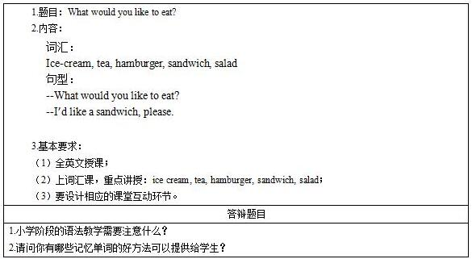
二、考题解析
《What would you like to eat?》主要教学过程及板书设计
教学过程
Step 1 Warming up and lead in:
Greeting with the students, have a free talk with the students, ask about the foods.
T: What’s your favorite food?
S: I like cake best.
T: Why do you like cake best?
S: Because the cake is very sweet, I like sweet.
T: Who can list some other food which is sweet? Are they the Chinese food?
S: No, the Chinese food is not always sweet.
T: Can you list some other Chinese food?
S: Rice, dumplings, and noodles.
T: We are going to learn some western food. Please look at the PPT.
Step 2 Presentation
Create the situation that the teacher is going to have a birthday party, and invites students to her party, ask about their favorite foods and then chose the restaurant.
T: Today is my birthday. I’d like to invite you to a restaurant to celebrate my birthday. What would you like to eat? (Write the sentence on the blackboard: What would you like to eat?)
Lead the students to answer: I’d like to eat…., and then ask them: What would you like to drink? Lead the students to answer: I’d like to drink….
Teacher list the foods students mentioned about just now, write ice cream on the blackboard, and then ask them what kind of ice cream they like to eat best?
T: Ok, now look at here, the first is ice cream. What kind of ice cream do you like best? I like strawberry best.
S:…
Write sandwich and hamburger on the blackboard, and then show them pictures of them to the class and say something about them.
T: You must be familiar with these two words, one is hamburger (Write hamburger on the blackboard), the other is sandwich (Write sandwich on the blackboard) .Where do we usually buy hamburger?
S: In KFC or Macdonald.
T: When we are hungry we usually have a hamburger. But some of us want to keep healthy, so they prefer to have some salad.
Show the picture of salad to the students and then write the word on the blackboard. Tell them we have many kinds of salads, and show them the vegetable salad, the fruit salad, the egg salad and some other salads.
Step 3 Practice
Prepare some cards with the words and give the cards to the first students in a row, after telling the words in a loud voice, pass it quickly to the next one, and then change the cards until all of them read all the cards.
Prepare some cards of food, and then use some words to describe it and ask students to guess the food, and find it in the cards and then paste it on the blackboard. After pasting it on the blackboard, teacher shows them the right answer on the blackboard.
T: The first one is a Chinese food, we often eat it with the vegetables and meat, what’s this? You, please. Ok, he chooses the rice card, please paste it on the blackboard. Everybody look at the PPT, the answer is rice! You are right.
After pasting all the cards on the blackboard, ask students to listen carefully, and then teacher reads the words at random, and after saying it for the first time, ask some of them to the blackboard to show the right order to the students.
T: Listen to me carefully, hamburger, sandwich, tea, rice, cake. Ok, who can come to the blackboard and show me the right order? Ok, you please.
T: Right, let’s have a check, the order is: hamburger, sandwich, tea, rice, cake.
Step 4 Production
Write the foods and drinks on a paper, and use it as a menu, teacher acts as the waiter, students act as the guest, make dialogue with students.
T: What would you like to eat?
S1: I’d like a sandwich.
T: What would you like to drink?
S1: I’d like a cup of tea.
Change another one to ask.
T: What would you like to eat?
S2: I’d like a hamburger.
T: What would you like to drink?
S2: I’d like coca-cola.
After making the dialogue with the students, ask them to practice the sentences with their partner, and then ask some of them to show it to the class.
Step 5 Summary and homework
Summary: Ask one of them to have a summary of what we learned today, some students say the words, the others say the Chinese meaning.
Homework: Ask them to make a table after class, write Chinese food in one line, the western food in another line. Try to recall all the foods we learned in this table, and add more other food in this table.
板书设计
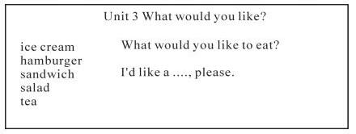
答辩题目解析
1.小学阶段的语法教学需要注意什么?
【参考答案】
其实语法教学是比较枯燥的，但是作为教师，要具备化腐朽为神奇的技能，在语法课的教学当中时刻注重抓住学生的注意力，将所学知识进行适当的变式，让学生在一种轻松愉快的环境当中快乐的学习语法知识。
这节课主要学习了三个介词，在导入环节先设置一个比较吸引学生的猜谜游戏，呈现出本节课需要利用的教具盒子和铅笔，但是在铅笔的呈现方式上没有直接展示给学生而是让学生进行猜测，在导入环节就吸引住了学生的注意力，在吸引了学生注意力的基础上抓住学生的兴奋点立刻讲授要学习的三个单词利于学生理解。当然语法学习最重要的是要讲知识点带入到所学的句型当中，所以在学习完三个介词之后立即带领学生进行练习，巩固语法知识，在巩固知识之后立刻加入学习的两个语法句型，让学生学以致用，在兴奋点最高的时机教授最重要的知识点，之后再进行巩固。
总之语法教学虽然枯燥难懂，但是教师只要注意授课的形式多和实物结合多做练习，抓住学生兴趣点在最好的时机进行授课会是会产生到意想不到的效果的。
2.请问你有哪些记忆单词的好方法可以提供给学生?
【参考答案】
可以利用联想记忆、谐音记忆和利用卡片进行记忆。
首先联想记忆是因为小学生对形象直观的事物比较感兴趣，把单词联想成生活中常见的一些事物能帮助学生记忆。如eye把两个e想象成两只眼睛，把y想象成鼻子。
其次谐音记忆也可以帮助学生快速的记住单词，例如pest是害虫，那一想到害虫我们都想到拍死他，这个谐音和单词的读音很像，除此之外还有sunny这个单词，可以读成晒你，根据读音进行拼读记忆。
卡片记忆法就是将单词整理或写在卡片上，可供随时翻阅并加以记忆。这种方法的特点是简单实用并易于携带，不受时间和空间的限制，可随时随地随用。这样不仅可以寓学于乐，而且还可以大大提高对课余时间的合理有效利用。
除此之外还要注意结合艾宾浩斯遗忘曲线进行记忆，因为我们学习完一个新的知识之后是先忘得比较快后忘记的慢，建议学生在刚学完单词之后多记忆，以免遗忘。
​

