为方便广大教师资格面试考生考试，小编特整理了2017上半年教师资格证面试真题及解析：小学语英语（第二批）。
2017上半年教师资格证面试真题及解析：小学语英语(第二批)
小学英语《What time is it?》
一、考题回顾
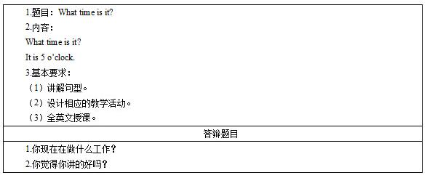

二、考题解析
小学英语《What time is it?》主要教学过程及板书设计
教学过程
Step 1: Warming up
(1)Greeting with the students.
(2)Do the warming up with students and review the numbers:
One finger one finger turn turn turn, turn to a toothbrush, shua shua shua~ Two fingers two fingers turn turn turn,turn to a rabbit, jump jump jump~ Three fingers Three fingers turn turn turn, turn to a cat, miao miao miao…
Step 2: Presentation:
(1) Show the picture of a clock, then ask the students the question what time is it? Help the students answer the question with the sentence “It’s…o’clock”. In this time, the teacher will only point on the hour.
(2) Show some pictures of the daily life and there is a clock in every picture and ask the students to describe the time in with their deskmates.
(3) The students may have doubt with the last picture, the time in the last picture is 10:17and the teacher will ask the students to give the question “what time is it” to the teacher. The teacher will answer the question and guide the students learn the time expression.
Step 3: Practice
The teacher will play the game Touch and Say with the students. The teacher will hold two different clock on his/her hand and invite the students to ask ”what time is it”. When the teacher answers the question the students should touch the right picture.
Step 4: Production
(1) Ask students make a clock by themselves and ask their partner what time is it by changing the time.
(2) The teacher will ask four students in a group and have a competition. The representatives from every group write down the time they hear. Who get more right answers, who will be the winner.
Step 5: Summary and homework.
(1) Ask two or three students to give a summary of the class.
(2) Ask students to describe the time when they go to school, when they have lunch and when they go to bed.
板书设计
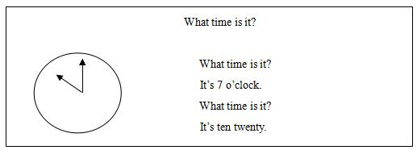
答辩题目解析
1.你现在做什么工作?
【参考答案】
大学毕业后，我在一家课外辅导机构做一名英语老师，虽然工作时间不长，但是我十分喜欢这份职业，并且学到了很多东西。首先，这份工作和我专业相符，使我在校所学得到了真正应用，其次，通过这份工作，我学到了很多小学生英语教学的方法，包括一些有趣的游戏和歌曲，更重要的是，当我看到孩子们一张张天真的笑脸，我获得了很大的满足感。
2.你认为你这节课上的好吗?
【参考答案】
我认为我这节课有优势，同时也存在不足。首先，本节课重难点突出，完成了预设的教学目标，学生通过与老师的对话，自然而然地学习了本节课的重点句式，并且还进行了一定的拓展延伸，其次，在教学过程中，充分体现了学生的主体地位，通过游戏和对话，吸引学生注意力，帮助学生练习新句式。再次，巩固提高环节也符合学生的特点，通过竞赛的方式，提高学生兴趣，帮助学生将所学句式应用到实践过程中。但是本节课也存在不足之处，游戏环节偏多，可能会导致预设环节不能按时完成，在实际教学过程中，我会根据实际情况调节我的环节和进度。

